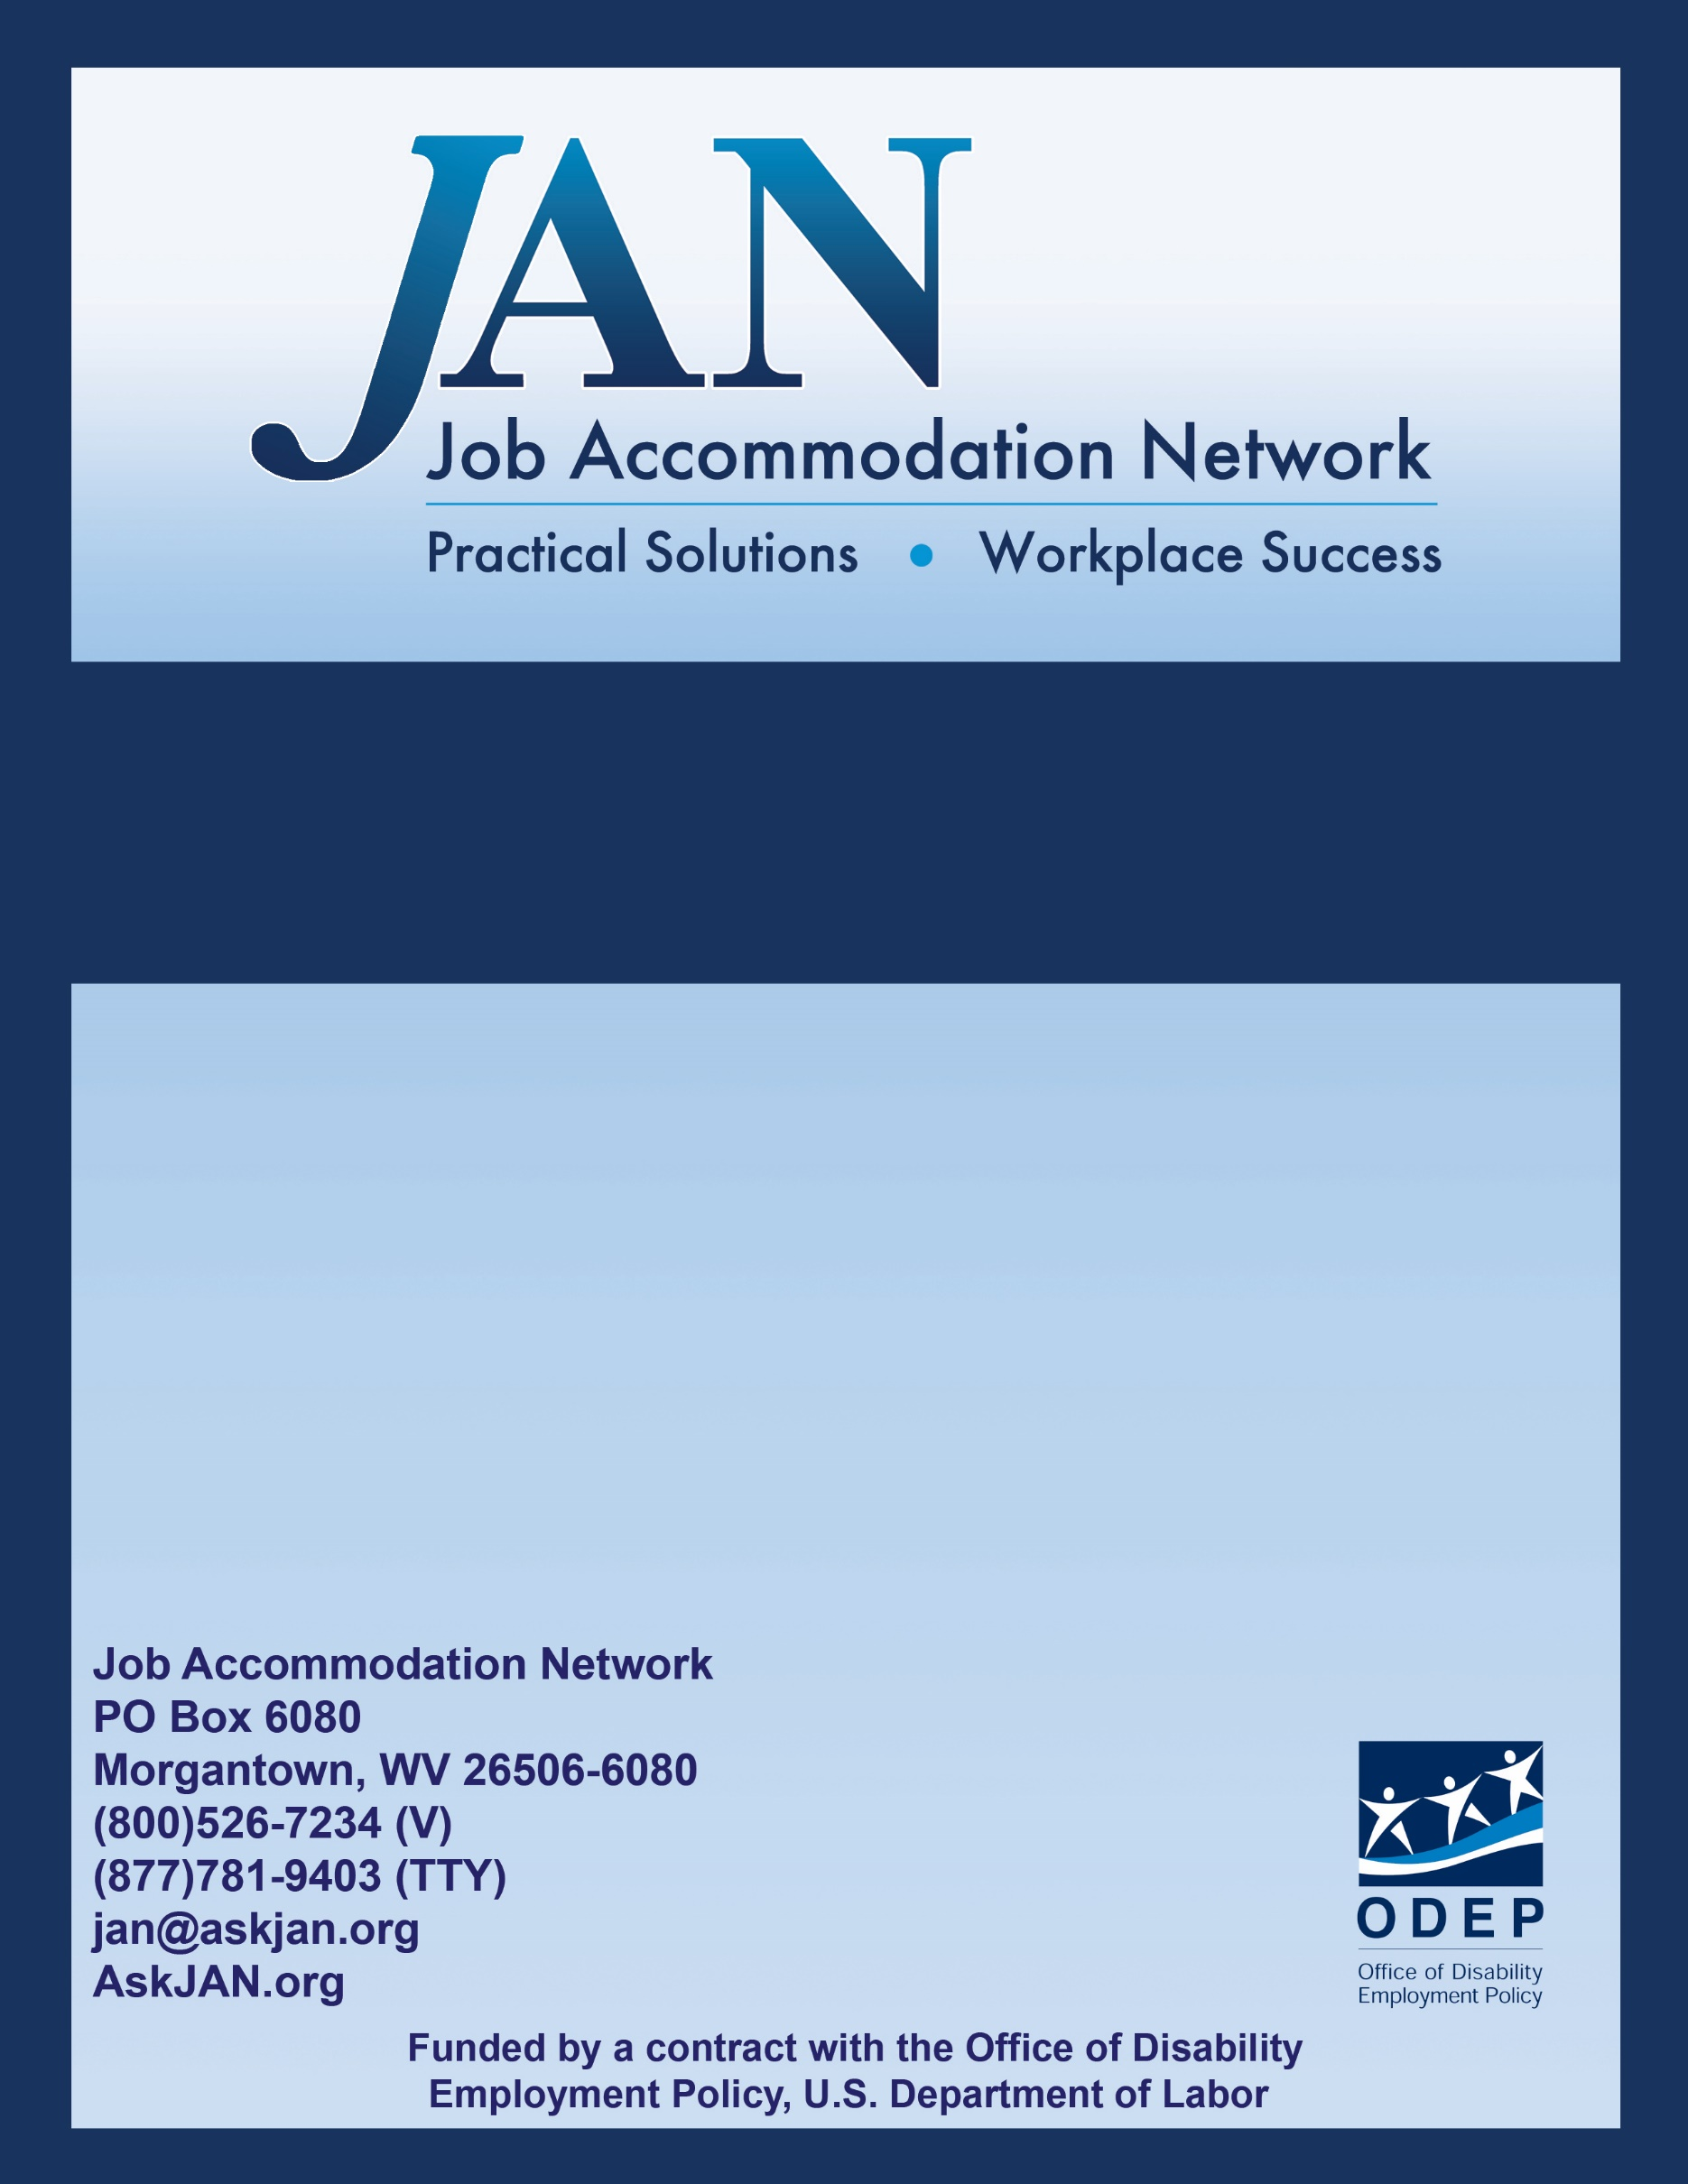
Effective Accommodation Practices
(EAP) Series

Addressing Workplace Harassment:
Employer’s Responsibilities

JAN’S EFFECTIVE ACCOMMODATION PRACTICES SERIES

Information about Workplace Harassment
Workplace harassment has been given many labels, including bullying, harassment, workplace violence, and mobbing (Schindler, 2014). Mobbing entails multiple people bullying or harassing one individual (Vickers, 2009). The United States government defines workplace harassment as “unwelcome conduct that is based on race, color, religion, sex (including pregnancy), national origin, age (40 or older), disability or genetic information” (U.S. Equal Employment Opportunity Commission, Harassment, § 2). “To be unlawful, the conduct must create a work environment that would be intimidating, hostile, or offensive to reasonable people” (ibid, § 3).
Harassment may be committed by any employee, including co-workers, supervisors, support staff, employers or non-employees (e.g., delivery people or contractors). Likewise, any employee can be harassed by one or more others, although it is unlikely for a person with little power to harass a person with greater power within the organization.
There is some evidence that people with disabilities may be at increased risk of workplace harassment. Much of the research on harassment of people with disabilities has been conducted with children and adolescents within the school environment. This research suggests that those with emotional or behavioral disorders are at greater risk of harassment than others (e.g., Blake, Lund, Zhou, Kwok & Benz, 2012). Individuals with emotional or behavioral disorders may be viewed by others as a nuisance or thought to willfully engage in behaviors that may be disruptive. Consequently, others may engage in harassing or even aggressive behaviors toward them.

Addressing Workplace Harassment
Workplace harassment is considered a form of discrimination, and is therefore a violation of federal law. It is considered a violation of Title VII of the Civil Rights Acts of 1964, the Age Discrimination in Employment Act of 1976, and the 1990 Americans with Disabilities Act. Harassment must be addressed once it has occurred.
If you become aware that someone is being harassed at work:
- The best response to workplace harassment is prevention. As an employer it is imperative that you develop a culture of respect. It is also important that you clearly communicate to all employees that harassment will not be tolerated.
- Document the words or language used that constitute the harassment. Remember, words are harassment when a reasonable person would feel uncomfortable, intimidated, threatened, unwelcomed, degraded, humiliated, or would view the language as offensive (Von Bergen, Zavaletta & Soper, 2006).
- Document the specific behaviors that constitute the harassment. Harassing behaviors may lie on a continuum, from incivility to physical violence (Von Bergen et al., 2006). Some behaviors that have been identified as bullying or harassment include humiliating treatment, exclusion, “unrealistically high workloads or deadlines, and physical intimidation or abuse” (Altman, 2010, p. 22).
- Address the harassment with the alleged offender. Provide as many details of the harassment as possible. With the lists of language and behaviors in writing you will be able to stay focused and to the point. Follow all legal standards during this meeting, including allowing the employee to voice his or her perspective of the harassment.
- Should there be sufficient evidence that the harassment occurred, follow established policies and procedures in helping the victim to recover and the harasser to learn from the experience. The goal is to stop future workplace harassment.

Resources
The United States Equal Employment Opportunity Commission’s website offers important information about your rights as an employee. Follow the link to legal information about workplace harassment: http://www.eeoc.gov/laws/types/harassment.cfm

The US EEOC website also offers information about illegal discrimination at http://www.eeoc.gov/laws/types/disability.cfm
The United States Department of Labor (DOL) has an informative website about unlawful workplace harassment for DOL employees, although the information is helpful to others: http://www.dol.gov/oasam/programs/crc/2011-workplace-harassment.htm

References
Altman, B. (2010). Workplace bullying: Application of Novak’s (1998) learning theory and implications for training. Employee Responsibilities and Rights Journal, 22, 21-32. DOI: 10.1007/s10672-009-9121-7
Blake, J. J., Lund, E. M., Zhou, Q., Kwok, O., & Benz, M. R. (2012). National prevalence rates of bully victimization among students with disabilities in the United States. School Psychology Quarterly, 27, 210-222. DOI: 10.1037/spq0000008
Schindler, E. (2014). Workplace violence: Extending the boundaries of criminology. Theoretical Criminology, 18, 371-385. DOI: 10.1177/1362480613511980
U.S. Equal Employment Opportunity Commission (n.d.). Harassment. Retrieved from the world-wide web: http://www.eeoc.gov/laws/types/harassment.cfm
Vickers, M. H. (2009). Bullying, disability and work: A case study of workplace bullying. Qualitative Research in Organizations and Management: An International Journal, 4, 255-272. DOI: 10.1108/17465640911002536
Von Bergen, C. W., Zavaletta, J. A., & Soper, B. (2006). Legal remedies for workplace bullying: Grabbing the bully by the horns. Employee Relations Law Journal, 32(3), 14-40.

Authored by Jeff Daniels, Ph.D., Updated 05/31/2018

This document was developed by the Job Accommodation Network, funded by a contract from the U.S. Department of Labor, Office of Disability Employment Policy (#1605DC-17-C-0038). The opinions expressed herein do not necessarily reflect the position or policy of the U.S. Department of Labor. Nor does mention of tradenames, commercial products, or organizations imply endorsement by the U.S. Department of Labor.

