The HR Manager will use this job aid to view and to enter or edit Accommodation information for an Employee that is related to a Disability that has already been reviewed and approved. This process can also be used for future updates to this Accommodation.

Add/Edit Accommodation Information
HR Managers have access to edit the Accommodation information which is located in the Global Information section of the Personal Information portlet.

To edit Personal Information, complete the following steps:
1

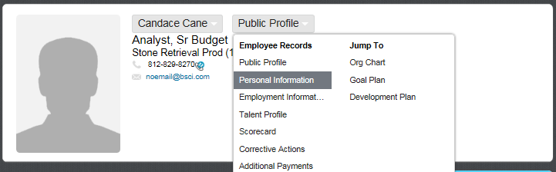
Log into the SuccessFactors Home page

- People Search Box: Find an employee by entering their name
into the People Search Box. When the employee's name
appears in the search results, click on the name to be
24
directed to the employee's Public Profile.

- Employee Records Menu: Click on Public Profile and
select Personal Information from the Employee Records
Dropdown Menu to be directed to the Personal Information page.

- Edit: Click on the Edit button on the Personal Information portlet.
You will be prompted to enter the date when the accommodation
will take effect. See Step 4 below.
3
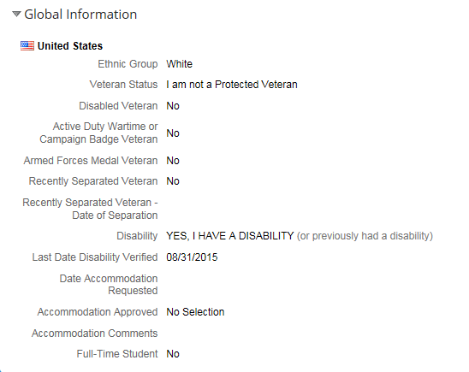
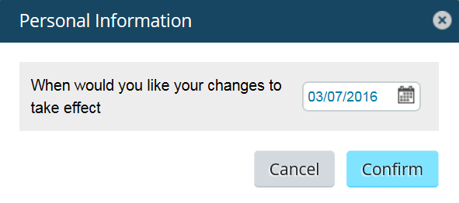
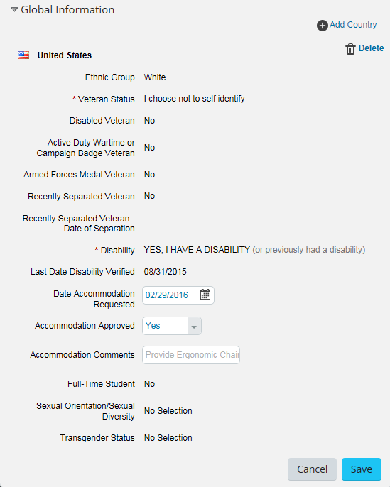
- Enter the date the accommodation will take effect. Click Confirm.
The Personal Information portlet will display with the effective date entered and
the accommodation fields will be opened for editing.
4

- In the Global Information section, Enter the Date the Employee requested the
Accommodation.

- Select Yes or No to indicate if the Accommodation Request was made.

- In the Accommodation Comments, Enter a brief description of the Accommodation
and the End Date, if applicable.
Example Accommodation Comments, but not limited to:
“Provide larger computer monitor.”
“Provide ergonomic chair. Raise desk height.”
“Limited phone work from 04/01/2016 to 04/30/2016”

- Save: At the bottom on the screen, click Save to save the changes.
5
8
7
6
- Once the changes have been saved, the accommodation information will appear in the
Personal Information portlet and will remain in the portlet History by Effective Date.
9
Effective as of: 03/07/2016
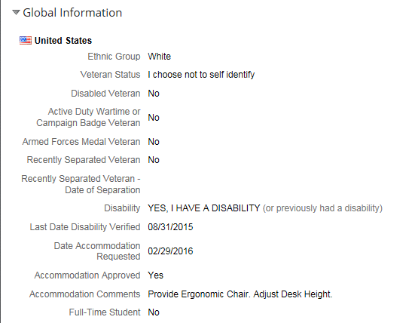

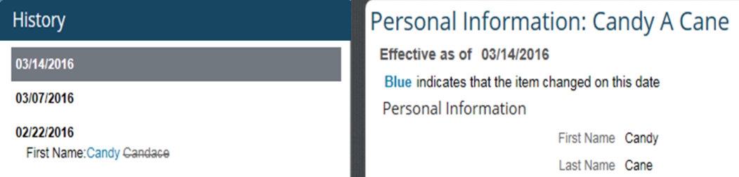

9

9

